Kerman Space Systems

R-3 Series of Carrier Rocket

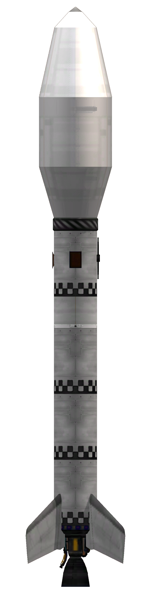
Operator’s Manual, volume 2
Kerbal Space Center flight operations
Table of Contents
Kerbal Space Center 3
Ascent profiles 3
MechJeb 2 ascent 3
SAS assisted ascent 5
Hybrid ascent 6
Manual ascent 6
Target orbit profiles 7
Equatorial 7
Polar 7
Performance data 8
R3-400-S1-H01N1X, equatorial 8
R3-400-S1-H01N1X, polar 8
R3-800-S1-H01N1X, equatorial 8
R3-800-S1-H01N1X, polar 8
R3-1200-S1-H01N1X, equatorial 8
R3-1200-S1-H01N1X, polar 8
R3-1200B-S1-H01N1X, equatorial 8
R3-1200B-S1-H01N1X, polar 8
R3-1200L-S1-H01N1X, equatorial 8
R3-1200L-S1-H01N1X, polar 8
Payload ejection 8
Deorbit burn 9
Combination deorbiting and inclination change 9
Direct deorbiting 9
Insertion to unstable orbit 9

Kerbal Space Center
Sited on the equator, the Kerbal Space Center is ideally suited for equatorial launches, especially for kerbostaionary orbit injection. The site borders the east sea at 75 degrees west.
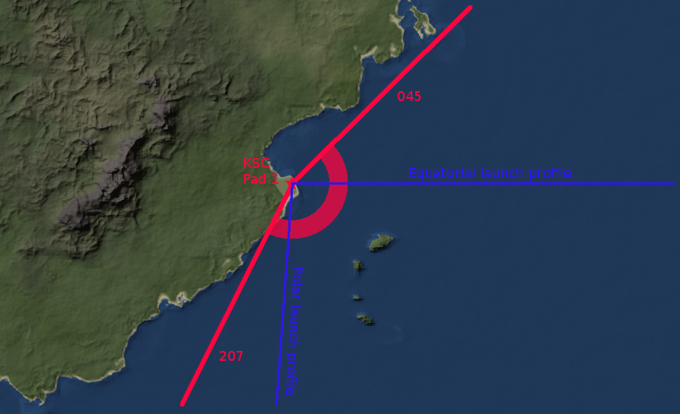
Launch heading is restricted between 45 degrees to 207 degrees to avoid overflying populated areas during launch. Launching from KSC, both equatorial and polar orbits are easily reached. Spacecraft can be inserted at any inclination for prograde orbits, and slightly retrograde orbits can be reached as well.

Ascent profiles
Multiple ascent profiles are available, depending on the techniques available and the desired precision and ease of use.

MechJeb 2 ascent
MechJeb, if available, is the simplest ascent mode. It is also fully automated and may not be desirable in certain cases. MJ2 ascents achieve reasonably precise orbital insertions, achieving especially good results with respect to final orbital inclination. MJ2 ascents are somewhat imprecise for long circularisation burns.
To execute a MechJeb ascent, select the ascent program “Stock style gravity turn” and program the following parameters.

 | Parameter | Value
TARGET | Orbit altitude (Km) | 80
TARGET | Inclination (deg) | As required by mission parameters
GUIDANCE | Turn start altitude (Km) | 0.5
GUIDANCE | Turn start velocity (m/s) | 50
GUIDANCE | Turn start pitch | As indicated by rocket performance graph
GUIDANCE | Int. altitude (Km) | 80
GUIDANCE | Hold AP time (s) | 1
OPTIONS | Prev. engine ovrheat | No
OPTIONS | Limit Q (Pa) | No
OPTIONS | Limit Accel (m/s^2) | No
OPTIONS | Keep limited throttle (%) | No
OPTIONS | Electric limit (%) | No
OPTIONS | Force roll climb-turn | 90-90
OPTIONS | Limit AOA (deg) | 5
OPTIONS | Dynamic pres FO (Pa) | 2500
OPTIONS | Autostage | Yes
OPTIONS | Autostage delay, pre (s) | 0.5
OPTIONS | Autostage delay, post (s) | 1
OPTIONS | Clamp autostage thr (%) | 0.99
OPTIONS | Stg frings, dyn prs (KPa) | 5
OPTIONS | Stg frings, altitude (Km) | 50
OPTIONS | Stg frings, flux (W/m^2) | 1135
OPTIONS | Stop at stage | 1 for single  2 for dual
OPTIONS | Auto deploy solar panels | No
OPTIONS | Auto deploy antennas | No
OPTIONS | Auto warp | As preferred
OPTIONS | Skip circularization | No

Other parameters should be left with their default values. All orbital and guidance parameters define how orbital insertion is done and should not differ from the data above.
The “stop at stage” parameter is set to exclude the payload staging. This is done to prevent premature ejection of inert payloads by MechJeb once the payload fairing is opened. If anything other than single stage payloads (e.g. payloads with kicker rockets) are placed in the payload bays, adjust the “stop at stage” value to one stage before the first payload decoupler (as a rule of hand, this is usually the stage number of the payload fairing).
The auto deploy options are set to false to prevent damage to the rocket and/or payload due to deployment inside the payload bay. This is especially true for lower payloads, and not critical for single or upper payloads. These switches may be toggled if it is determined that antenna and/or panel deployment will not interfere with proper operation of the spacecraft.
The initial gravity turn pitch should be decided taking the payload mass into account. For each payload mass, there should be an optimal angle, which minimizes propellant use. This angle has been recorded in performance envelope graph for each piece of tested hardware and launch profile. Next to this value are the 98% efficiency values. This values show the maximum and minimum angles that yield 98% of the delta V of the optimal angle. The outer values of the pitch angle table show the “never exceed” values. These are the hard limits of the gravity turn. Any attempted gravity turn that exceeds these values will likely cause the spacecraft to fail to orbit. Some of these failure modes are not correctable, and may not be immediately obvious.

SAS assisted ascent
SAS assisted launches are available for the case when MechJeb is unavailable or undesirable. This mode consists of doing a gravity turn, similar to Mechjeb’s, followed by a coast to apoapsis and circularisation burn.
SAS assisted ascents usually have a different pitch angle for optimum gravity turn performance, as it uses full pitch during the initial turn.
The ascent program for SAS assisted launches is shown below.
- Turn on SAS on stability assist mode
- Set throttles to 100%
- Activate the staging sequence to launch
- If necessary, rotate rocket so that the +Z side faces the desired orientation
  - This is usually done on the starboard side, which is already pointing to 090 degrees (due east)
  - For lower mass payloads and high TWR placing the launcher in an orientation different to the default may be necessary, if the roll cannot be completed before reaching turn velocity.
- Wait until speed relative to surface reaches 50 m/s
- Initiate a hard right turn, watch the velocity vector and wait until it reaches the desired angle
  - The winglets are calibrated as to prevent over-pitching when actuated at their maximum deflection
- When the velocity vector reaches the desired angle, set SAS to prograde mode
  - Alternatively, temporarily disable SAS and release controls to allow the winglets to passively stabilize the rocket. Activate prograde mode before activating the upper stage or at 10000 metres at latest.
- When propellants run out, activate the second stage, cutting thrust as soon as apoapsis reaches the desired altitude (usually 80 Km)
  - If apoapsis reaches the desired altitude before first stage cut-off, the climb was too steep. Consider aborting the mission or taking emergency action. Orbit may be achievable with light payloads. Consult the test data.
  - Alternatively, wait until apoapsis reaches 5km below intended orbit and reduce burn to minimum, adjusting altitude by actuating throttle during coast, if a single long burn is desired.
- Coast to apoapsis and wait until the tabled time for the current velocity, then set the throttle to 100%. Reduce throttle as apoapsis is pushed back. Try to keep the apoapsis time to close to 5 seconds. Do not pass apoapsis.
- Cut off upper stage engine when periapsis reaches intended altitude.

Hybrid ascent
The hybrid ascent combines the first part of the Mechjeb ascent with the circularization burn of the SAS ascent. This is particularly useful at the limits of Mechjeb ascent guidance capabilities. To execute a hybrid ascent follow the procedure below.
- Execute a MechJeb ascent until the Kerman line is reached.
- Disable MJ2 autopilot.
- Enable SAS prograde mode.
- If the payload fairing has not been ejected, eject it.
- Wait until the time for the circularisation burn is reached, and execute a SAS circulatisation.

Manual ascent
Manual ascent is identical to the SAS assisted burn with the following changes. This method is used when prograde mode is not available (e.g. with AR202 or OKTO computers).
- If SAS stabilization is available and used for turning, disable SAS after reaching the desired pitch.
- Let the fins stabilize the spacecraft until the first stage is jettisoned.
- Manually follow the prograde marker during second stage ascent, using any means available for that purpose.
- Once the apoapsis altitude nears the desired orbital altitude, throttle down and continue burn with reduced power until the apoapsis reaches the desired orbital altitude.
- Execute a SAS-style circularization burn.

Target orbit profiles

Equatorial
The equatorial orbital injection is a launch due east. It is used for orbiting various types of payloads, for trans-munar payloads, for injection kerbosynchorous equatorial transfer orbit or for direct interplanetary transfers.
Parameter | Value
Launch azimuth | 090 (east)
Inclination | 0 (prograde)
Altitude | 80 KM
Eccentricity | 0 (circular)

Polar
The polar orbital injection profile is a southbound launch used to insert payloads into polar LKO. Transfer to higher orbits is possible after orbital insertion.
Parameter | Value
Launch azimuth | 184 (roughly south)
Inclination | 90 (polar)
Altitude | 80 KM
Eccentricity | 0 (circular)

Performance data

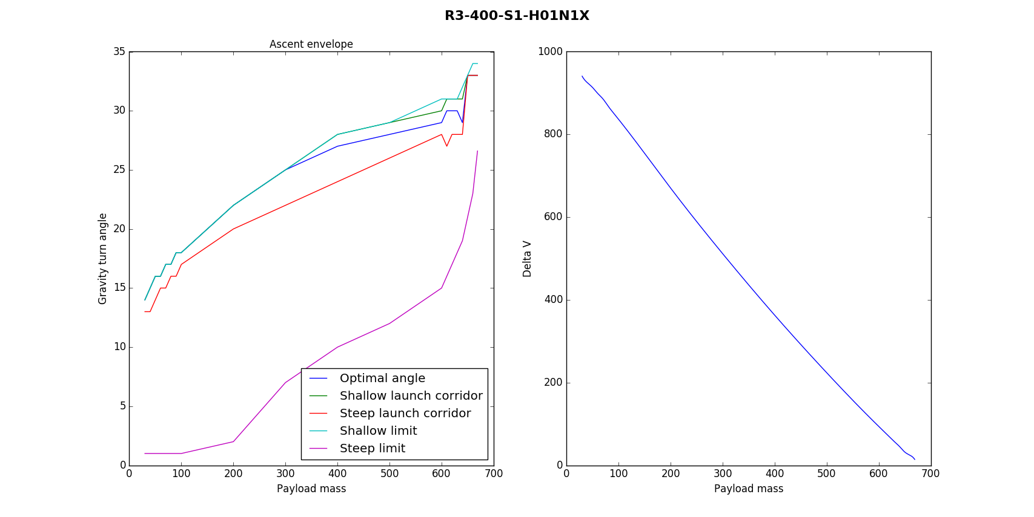
Equatorial launch profile
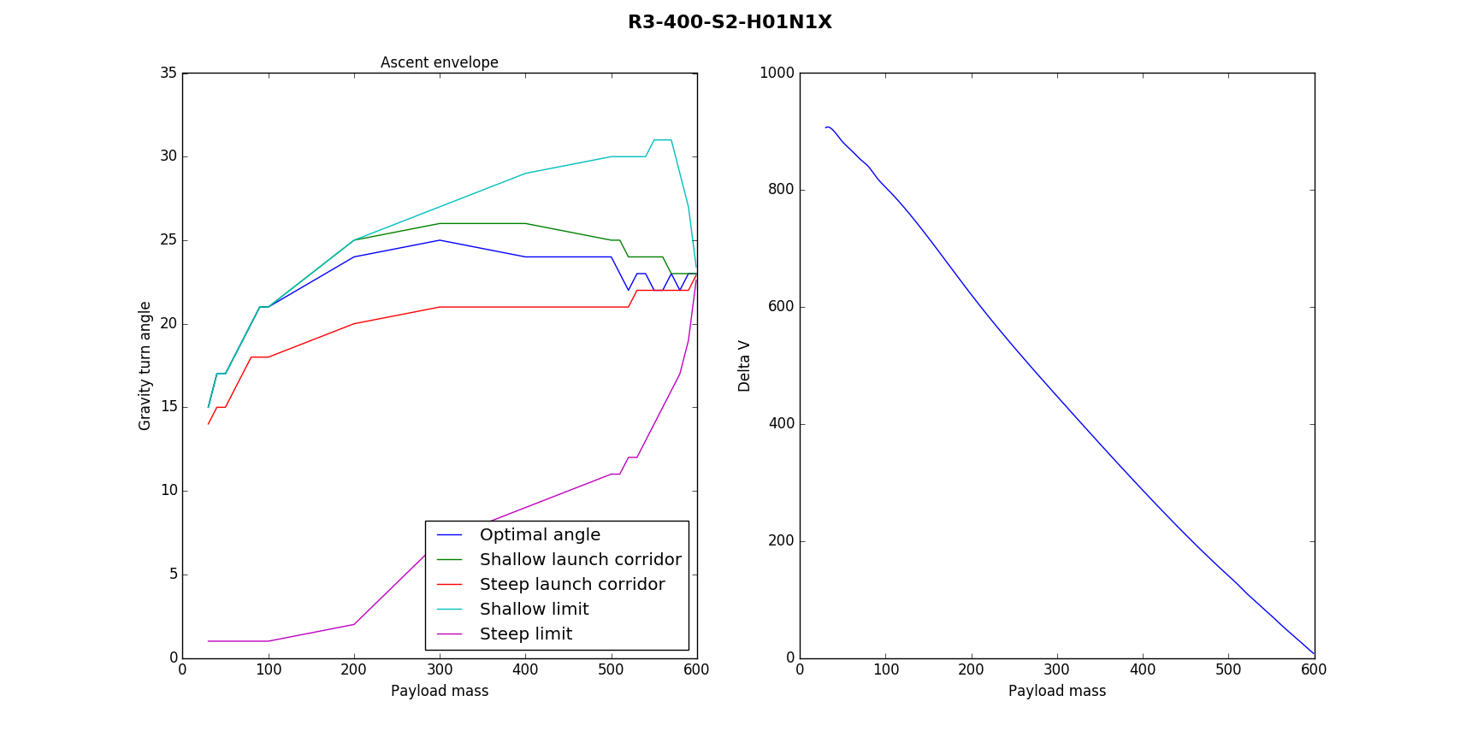

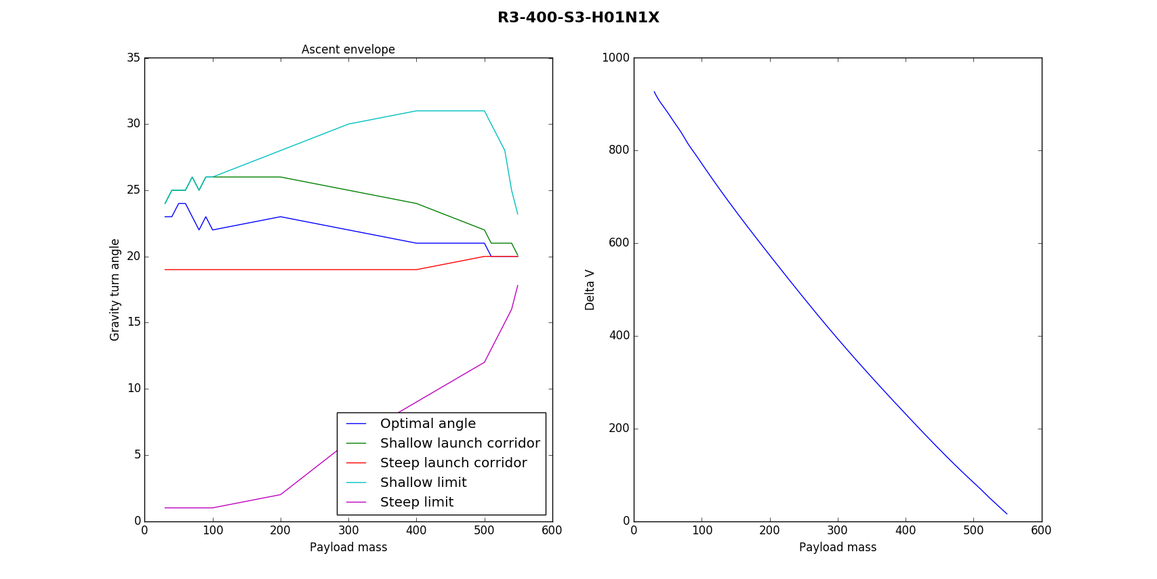
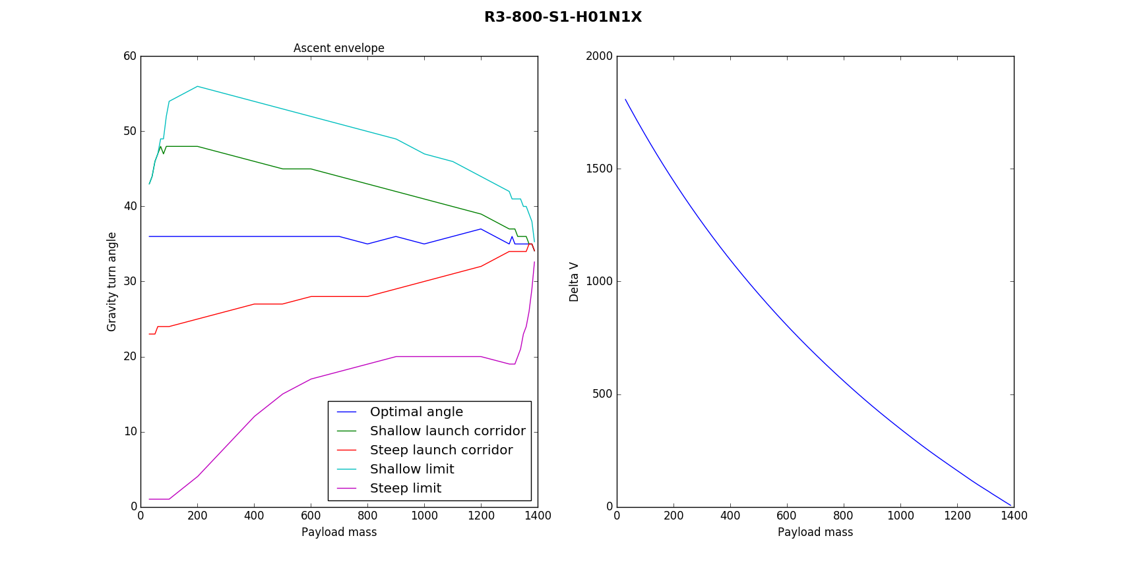
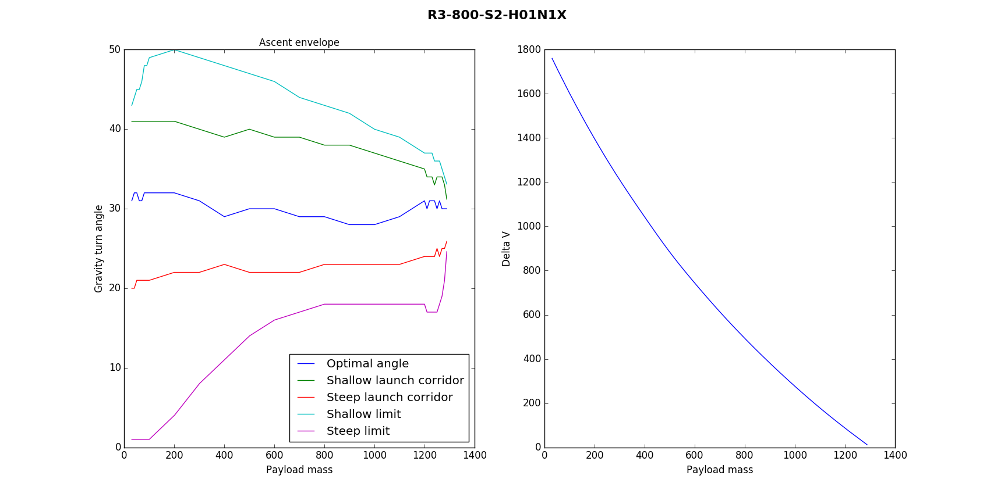
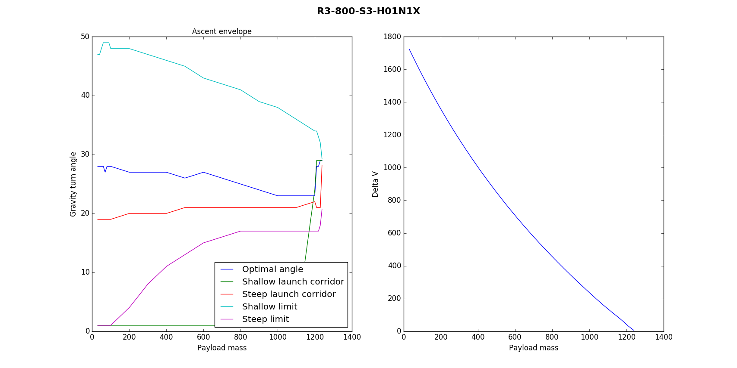
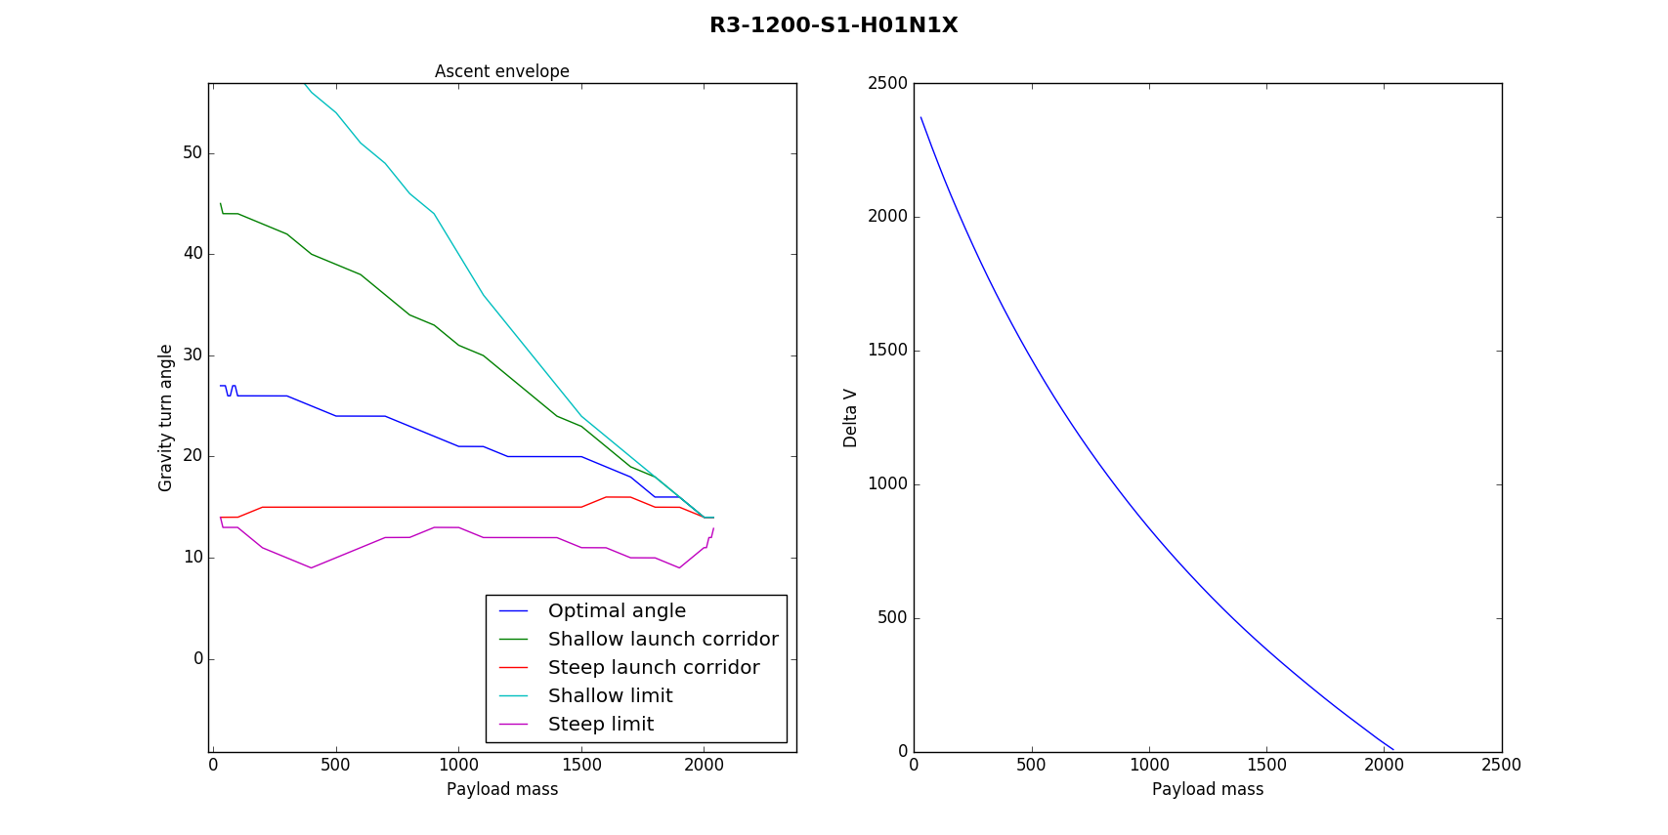
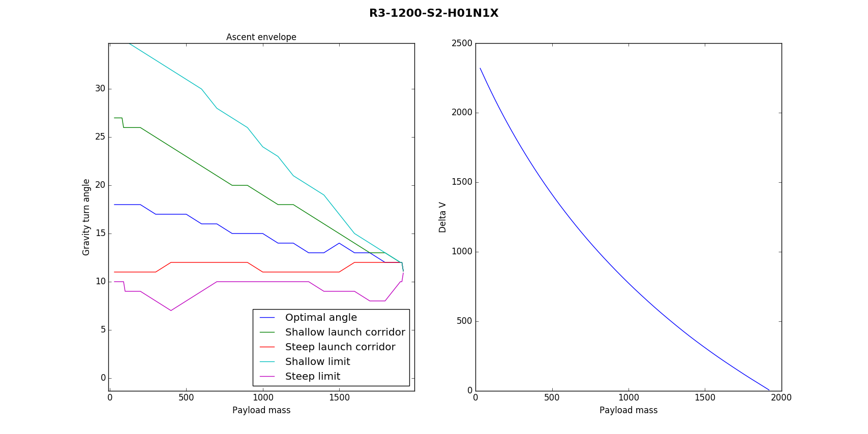
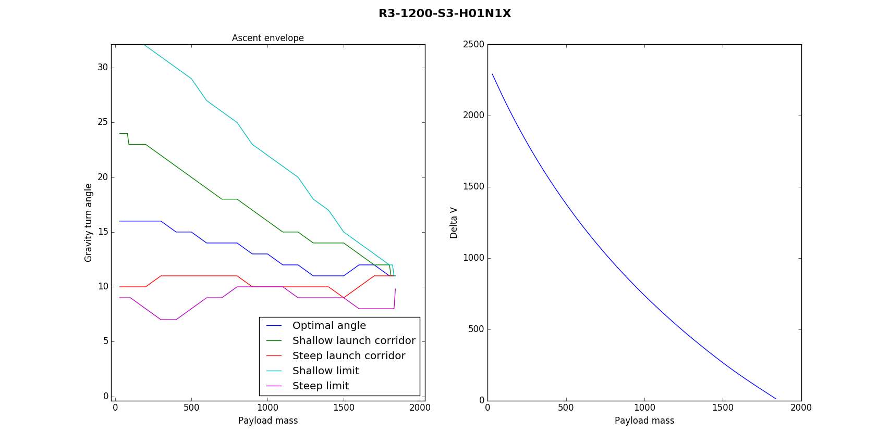
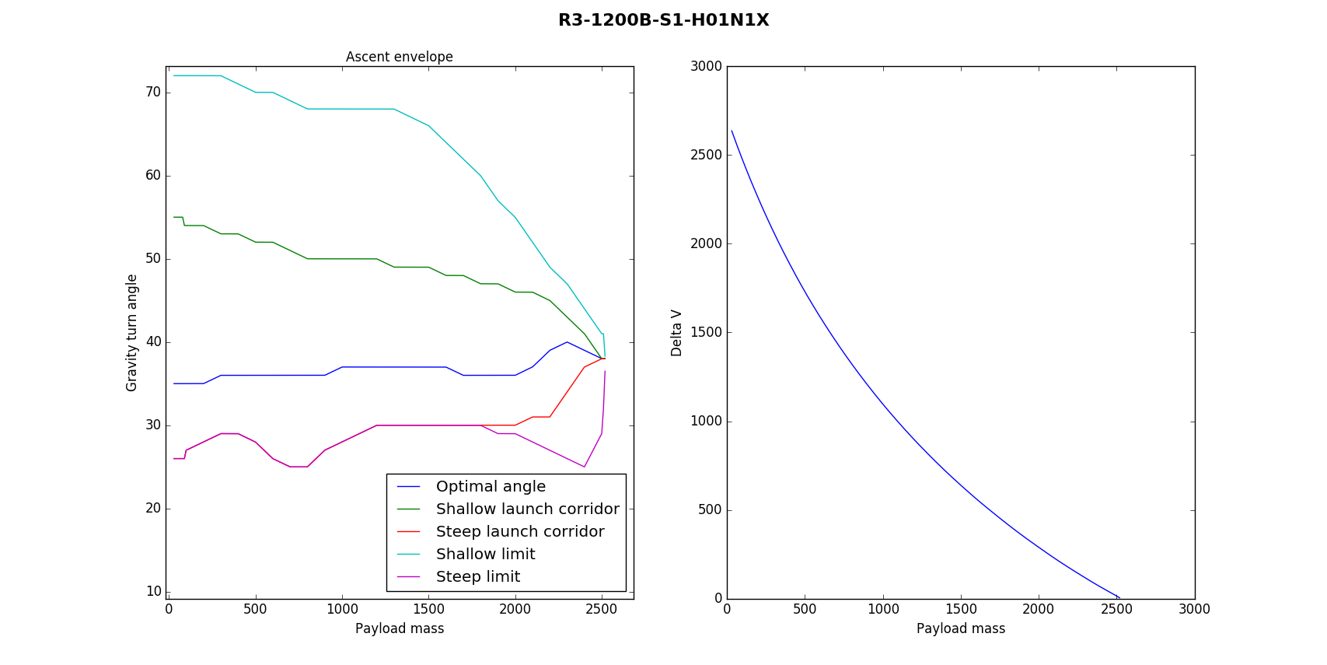
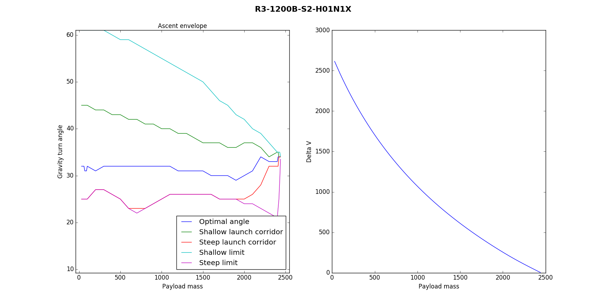
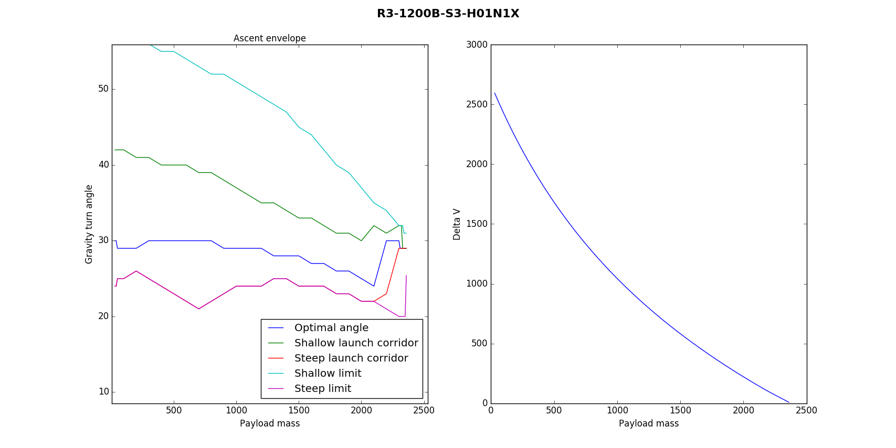
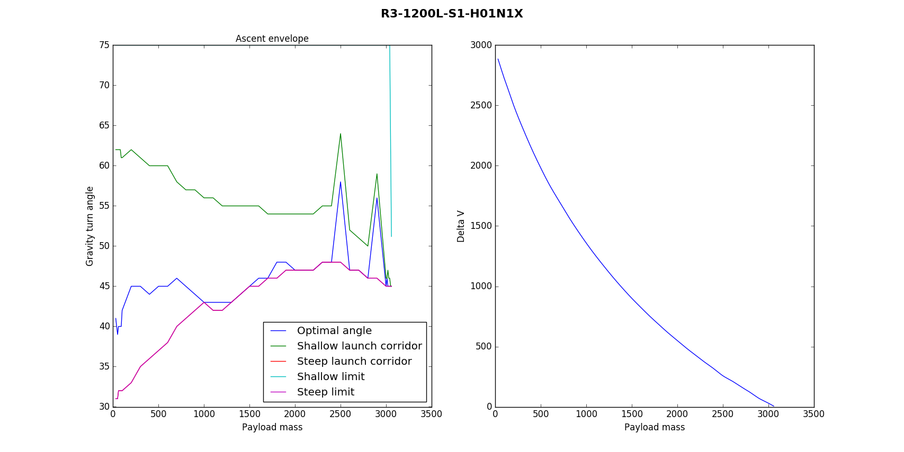
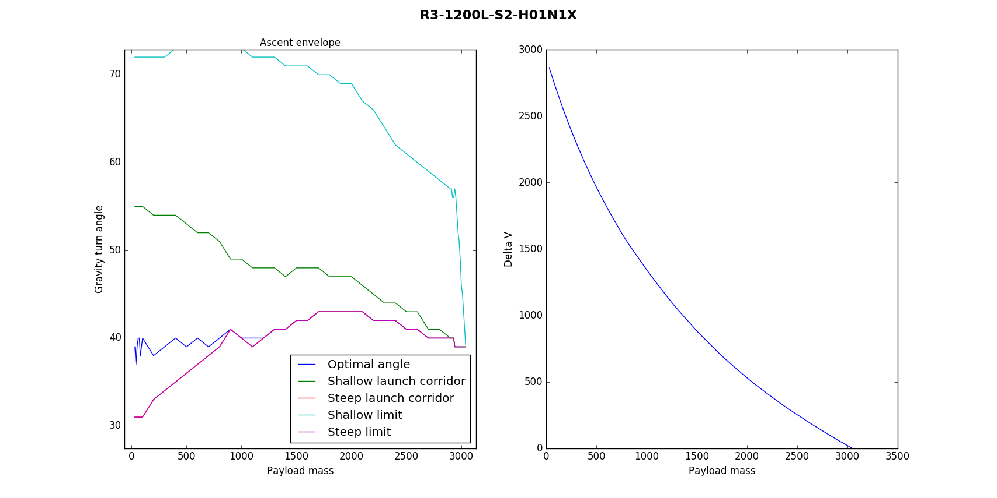
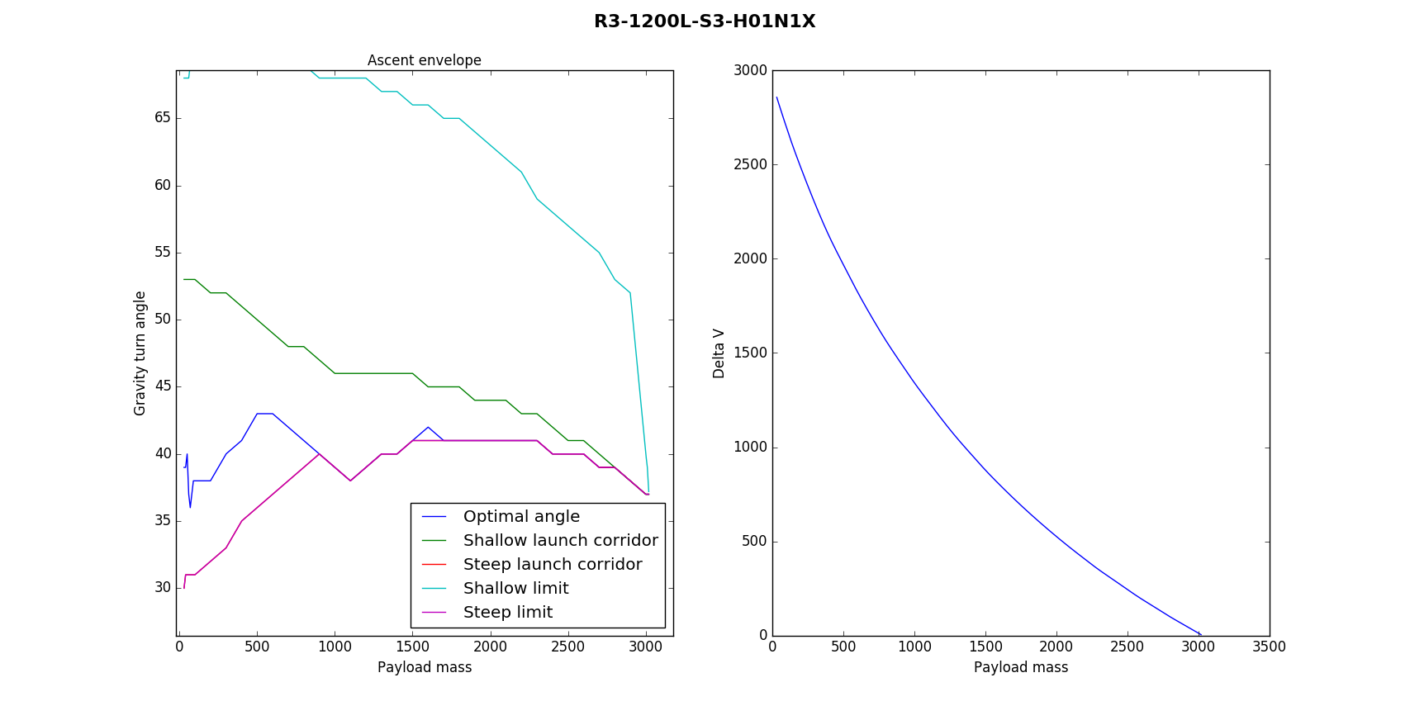

Payload ejection
Payload ejection for single launches should follow the standard procedure. Payloads are ejected using a decoupler, which applies a separation force. This applies to upper payloads in dual launches.
The lower payload of a dual launcher utilizes a zero ejection decoupler system and must be maneuvered out of the payload bay. There are several approved procedures.
- If the payload has RCS, apply a lateral translation burst to move it from the payload bay.
- If the payload has no RCS, but reaction wheels and a station keeping engine, rotate payload and apply thrust to clear the payload bay. Payload may bump into upper bay or lower bay supports.
- If payload engine fails, rotate the rocket after decoupling using the rocket’s reaction wheels (if available).
Bumping the payload bays during payload rotation may induce translation that could get a payload out of the bay, but this should be regarded as an emergency procedure only. Damage to payload or carrier rocket may occur if this procedure is used.
C type models are used as capsule service modules and should not normally be decoupled from the payload, as the capsule may need the module for propulsion. Ejection of C type upper stages are normally done after the final reentry burn. Read the capsule manufacturer’s documentation for the recommended procedure.

Deorbit burn
Most variants of the R-3 rocket have a flight computer and a small amount of battery capacity (or solar panels) to permit deorbiting of the spent upper stage once payloads are delivered. The procedure varies depending on the avionics and control systems available.
Deorbit procedures should commence as soon as the payload is released. Basic models have a AR202 computer with limited (5 unit) battery capacity. More advanced models have solar panels and larger batteries that extend the useful life of the rocket, allowing the execution of the deorbit burn at later, more convenient, times.

Combination deorbiting and inclination change
If the mission involves delivering payloads to a highly elliptic orbit with an inclination change, the burn may be executed at the node after periapsis, trading inclination for periapsis altitude. This type of burns leaves the payload in a suborbital trajectory, which requires the payload to complete its insertion burn at apoapsis or risk reentry.

Direct deorbiting
The usual mode of operation consists of executing a deorbit burn after delivering a payload to a circular low Kerbin orbit or elliptic orbit. This requires the rocket to turn to retrograde orientation and execute a burn using the remaining propellants.
The method of executing the turn depends on the control systems available. For models with reaction wheels, or OKTO and HECS computers the procedure consists of turning to retrograde using the wheels. Then, the engine can be fired.
For AR202 equipped models without wheels, rotation can be induced by steering the rocket (actuating the gimbals on the Terrier engine) and pulsing the engine once. Once the engine is about to pass the retrograde orientation, it can be fired to deorbit the rocket.

Insertion to unstable orbit
For payloads with a mass above, but close to, the rocket’s maximum payload, an incomplete orbital insertion may be executed. In this insertion profile, the rocket is burned until fuel exhaustion without reaching LKO, ideally with a periapsis altitude between 65 to 70 KM. The final insertion burn is executed by the payload’s apoapsis kicker motor. The rocket is left to reenter the atmosphere. This mode allows the use of a rocket without an onboard computer, while preventing the creation of debris in orbit and allowing parachute recovery of the upper stage at the same time.

Assumes single payload with no additional staging in each bay. Fully read this section and adjust properly if that is not the case.
Defined as 70Km over Kerbin surface. https://en.wikipedia.org/wiki/K%C3%A1rm%C3%A1n_line

